Arween Ismail

LSEG Python Test

***Data 1***

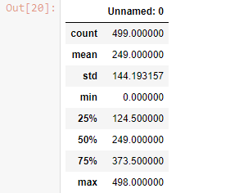

***Bar plot***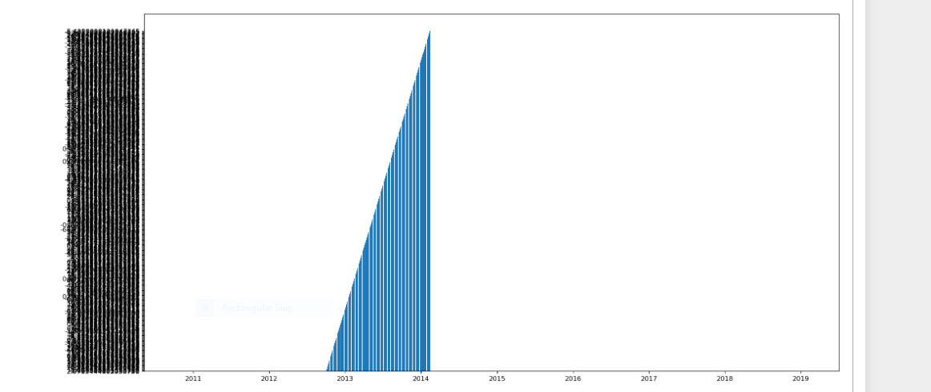

***Regression Assumptions for Test Data 1***

The dependent variable is revenue while time period was the independent variable.

* It is assumed that revenue figures are not a perfect correlation to each other.
* It is assumed that there is stationarity in the data.
* It is assumed that the data is sufficient.
* It is assumed that there is zero conditional mean.
* There is no autocorrelation between the error terms.

***Data 2***

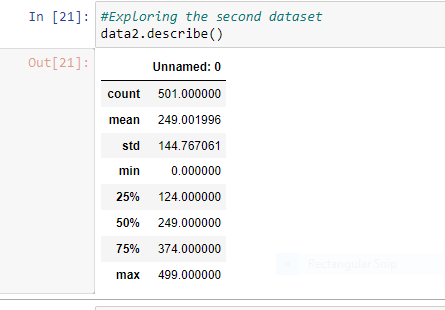

***Regression Assumptions for Test Data 2***

The dependent variable is sales while time period was the independent variable.

* It is assumed that the sales data (dependent variable) is independent
* It is assumed that the data is normally distributed
* It is assumed that the categorical data is independent